**SEEP Intake**

Rapid Report to Share Early Findings

21st June 2019



**Introduction**

This report serves to inform SEEP interim about findings of the Intake Interviews of the 300 savings groups that have been interviewed in Mali and Uganda.

For this report, we used a very straightforward format. We present the questionnaire that was administered. In the questionnaire, we have pasted the graphs of the results for Mali and Uganda separately.

For each graph, we write a short sentence summing up what can be concluded about the findings.

**Locations where the interviews took place**

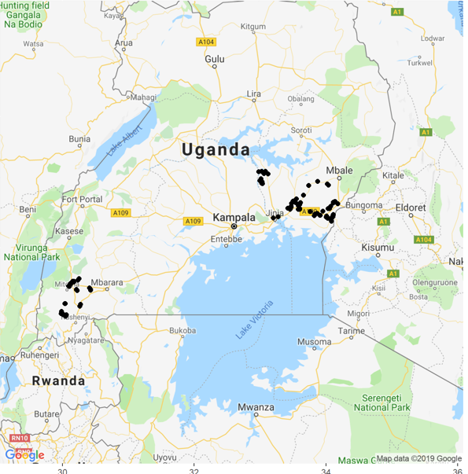

In Uganda, the groups interviewed covered 9 districts. Four districts in Western Region named Rukungiri (Rukungiri District Farmers’ Association), Kanungu (KIRDP), Buhweju and Bushenyi (Aprocel). Five districts in Eastern Region named Kamuli (Recode), Iganga (3 researchers, Iganga District Farmers’ Association), Bugiri and Busia (SEPSPEL), Tororo (Community Vision).

Detailed views of the Uganda locations are below:

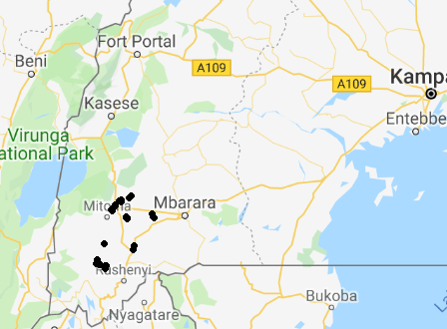

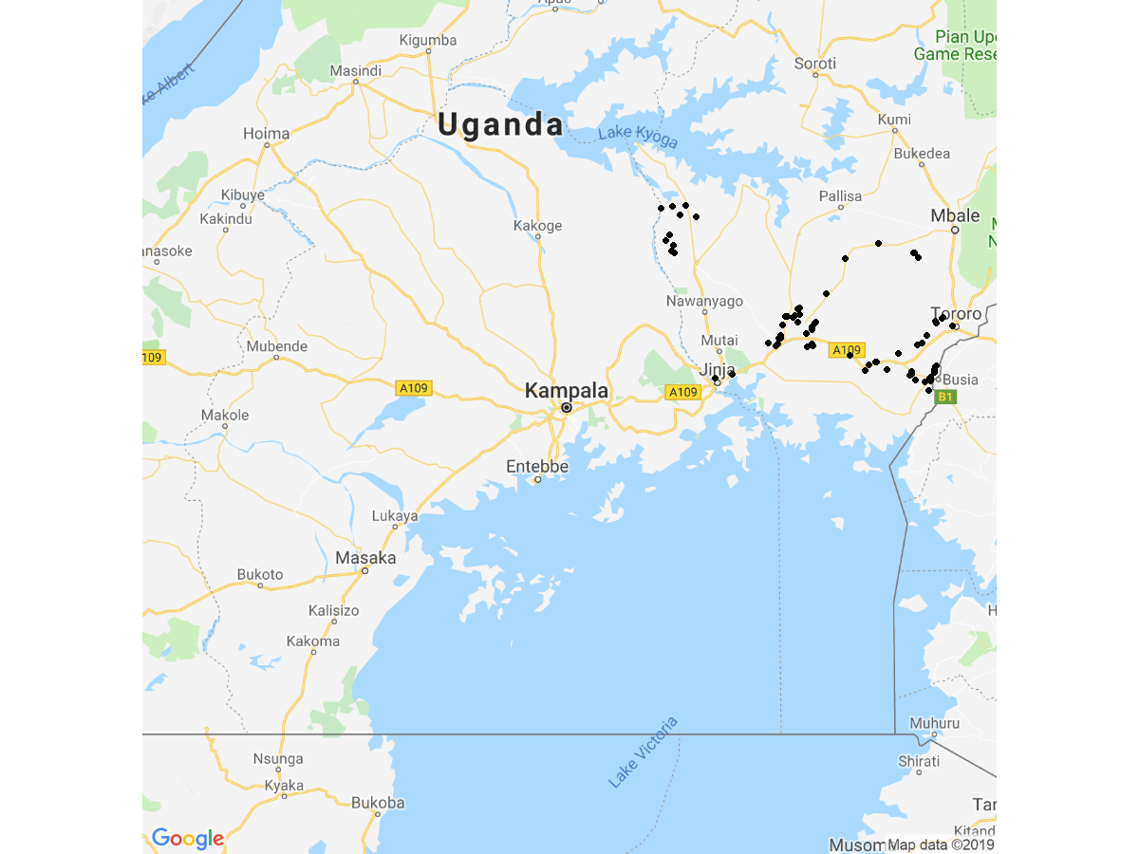

In Mali two cercles named Bougouni (where the organization CAEB was active) and Kalondieba (where the organization J&D was active) are included. Within these cercles seven communes are included.

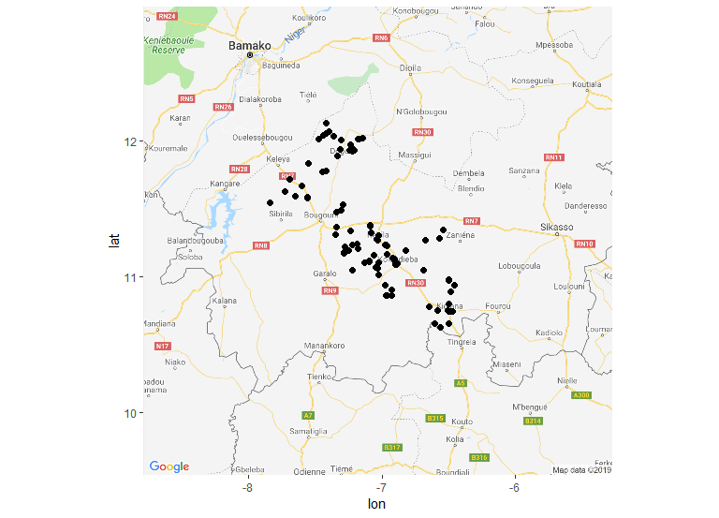

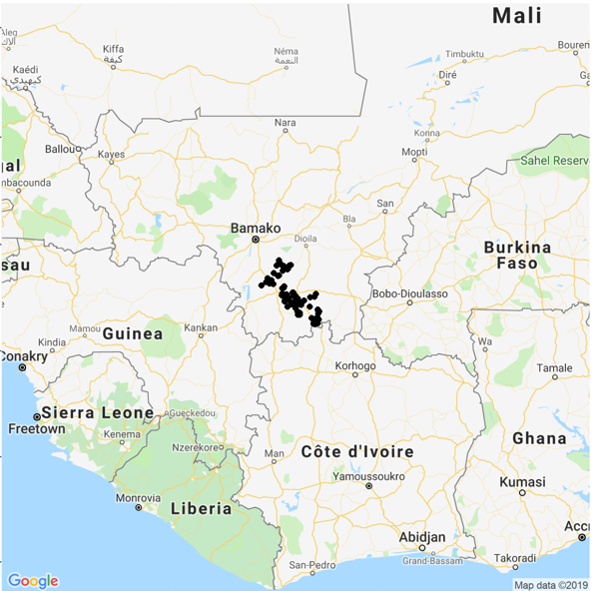

**Findings according to the questionnaire**

|  |  |  |
| --- | --- | --- |
| Question ID | Question | Answer |
| 1 | Greetings, my name is .... I am from L-IFT which is a company that does research about savings groups and VSLAs and the role savings groups have in members’ lives. This research will be used to help make VSLAs that will still be started better. I understand that you are part of the VSLA {0} . With your permission, I would like to visit your group for the coming three months so we can understand how you work, what you have learned, and if you have any challenges. I would like to start by asking you a few general questions about the group. This first interview takes about 15 minutes. |  |
| 2 | I will do my best to reduce the amount of time I ask from you, but your group will need to provide some information, and this will take some time. In exchange I hope the visits will be interesting for you and hopefully you will get some new awareness to help your group be even stronger. |  |
| 3 | This research is to learn what happened to the savings groups that were formed a long time ago. The research will interview 150 group in your country and another 150 groups in another country: Mali/Uganda. The research is very open-minded. It just wants to learn whether savings groups are still operating and how they are operating. There are no wrong or right answers. Do you allow me to interview you? We will be very careful with your information. It is confidential and we will not disclose to anybody what you said. We will only disclose for the entire research what all the respondents together said. Can I interview you now? Do you allow me to proceed? | Yes  No |
| 4 | The research will consist of 5 components: a. Census of savings groups (here we try to collect a full overview of existing groups in your village) b. Intake interview (that is this interview and it will last 15 minutes) c. Attending around 3 group-meetings over next 3 months (this will primarily be just observing the process of the meeting, without questions. At the end of the meeting I will have a few questions that will take 10 to 20 minutes and these questions are either asked to the group as a whole or to 1 or 2 individuals) d. Chairperson interview (this will take 30 to 45 minutes). e. Record keeper interview (this will take 30 to 45 minutes). This interview should take place with the person who maintains records. / MALI: I’d like to talk to the person who can best tell me how you keep records, how you know how much each person owes, and so on. |  |
| 5 | We are very careful that any information you give us remains confidential. We conduct the interview with each respondent privately and you and your group’s answers can never be traced back to you or your specific group. The information you provide will form part of a study of 300 VSLA groups in Mali and Uganda. If your group participates in the study I will bring detailed information about confidentiality and a form to provide consent at my first visit to your group. |  |
| 6 | Do you have any questions about what I have just said? [....................] (leave the respondent some time to consider and ask you questions. She/he may want to consult other group members.) Will you allow me to conduct this first interview with you? Please note at the end of this first interview there are still questions in which you can indicate in case you need to think more and need to discuss with other group members whether to participate. Is it OK I proceed? | Yes, we can do the interview now  Yes, we can do the interview but I want to make an appointment for another time  I am not sure, please call me later  No, I and my group refuse to participate |
| 7 | When can we make an appointment to do this first interview, the intake interview? |  |
| 8 | Please also provide me your contact details and for someone else. What is your name and what is the name of the other contact person? |  |
|  | *Name 1st contact person* |  |
|  | *Name 2nd contact person* |  |
| 9 | Could I please have your contact phone number? And the contact phone number of the other contact person? |  |
|  | *1st contact number* |  |
|  | *2nd contact number* |  |
| 10 | So you are sure your group doesn’t want to participate? | Yes  No |
| 11 | Why doesn’t your group want to participate? | Don’t have time  Don’t know you  Don’t trust you  Group has problems  Group has secrets  Group isn’t really functioning now  Bad experiences with research/visitors  Other |
| 12 | Please receive my phone number. If you change your mind, you can always call me and we can still work together. Would you mind if I take your contact details, just to check on you later whether you are sure you don’t want to participate? If so, Please provide me with your contact details: name, telephone number, telephone number of someone else who can reach you |  |

**Verification**

|  |  |  |
| --- | --- | --- |
| Question ID | Question | Answer |
| 13 | Please help me verify the following information I have about your group |  |
| 14 | Name of group {0}, is this correct? | Yes  No, please specify what is the correct name’ |
| 15 | Region {0}, is this correct? | Yes  No, please specify what is the correct name’  I don't know |
| 16 | District {0}, is this correct? | Yes  No, please specify what is the correct name’  I don't know |
| 17 | Parish {0}, is this correct? | Yes  No, please specify what is the correct name’  I don't know |
| 18 | Village {0}, is this correct? | Yes  No, please specify what is the correct name’  I don't know |
| 19 | Group number {0}, is this correct? | Yes  No, please specify what is the correct number  I don't know |
| 20 | Date first training started {0}, is this correct? | Yes  No, please specify what is the correct date  I don't know |
| 21 | Number of members at group formation {0}, is this correct? | Yes  No, please specify what is the correct number  I don't know |
| Adm1.PNG | | |
| In Mali, all groups started off with 30 members. In all groups, there were originally 25 female and 5 male members, according to the administrative data.  Currently, Mali has a median group size of 24 members. Only 25 percent of the groups are larger than25 and 25 percent of the groups are smaller than 16.  In Uganda, the groups were also all 30 on formation. There the distribution between male and female members varied. Median groups had 22 women members and 8 men members. Currently, the groups in Uganda are median size 30 and only 25 percent below 30 in size. The groups appear to have grown on average with 25% being between 30 and 34 in size and another 25 percent larger than 34. Reportedly there is also one group with 200 members but that is not included in this graph (was assumed an outlier but it really is a verified group now). | | |
| 22 | Women members {0}, is this correct? | Yes  No, please specify what is the correct number  I don't know |
| 23 | Name of chairperson {0}, is this correct? | Yes  No, please specify what is the correct name’  I don't know |
| 24 | Trainer name {0}, is this correct? | Yes  No, please specify what is the correct name’  I don't know |
| 25 | The information I just listed to you about the group, name, chairperson, number of members, does this sound like your group or does it actually sound like another group? I know it is a long time ago but if you think the information is wrong, please tell me about it.” | Information is correct and sounds like my group  Most of the information is correct but some I don’t recognize  Information seems wrong, not from our group  other (specify) |
| int 25.PNG | | |
| In Uganda, the vast majority of the groups confirm that they are the group that is on our list. Only in 6.5 percent of the cases the respondent of intake said that the group does not match with her / his group. (In these cases the groups were replaced). | | |
| int 25-1.PNG | | |
| In Mali, all the groups confirmed that the information was correct and that they were the group that was on file. | | |

**Chapter 3**

|  |  |  |
| --- | --- | --- |
| Question ID | Question | Answer |
| 26 | How much was the fixed savings amount during the first cycle? (Mali) |  |
| 27 | How much was the share amount during the first cycle? (Uganda) |  |
| Int 26.PNG | | |
| Int 26-1.PNG | | |
| In Mali, the fixed savings amount was median 100 CFA (about 0.17USD at current exchange rate). This was the value of the fixed savings amount at first cycle for more than half the intake groups. About one-third of the groups had a larger fixed savings amount per member. About 8 percent had 200 CFA fixed savings amount and about 10 percent 250 CFA. Only a handful of groups started off with a fixed savings amount larger than 250 CFA. | | |
| int 27.PNG | | |
| int 27 -1.PNG | | |
| In Uganda, the median share amount was 1000 UGX (around 0.27 USD at current exchange rate). However, since one member can save up to five shares, the savings amounts in Uganda were substantially higher when starting than Mali. About 30 percent of the groups had 500 UGX as starting share value, and about 10 percent had 2000 UGX as share value and a handful had a higher share value: 2 groups of 2500 UGX and about 8 groups of 5000 UGX. | | |
| 28 | How often did the group meet in the first cycle? | Weekly  Every 2 weeks  Monthly  It is not regular  Other (specify)  I don’t know |
| int 28.PNG | | |
| In Uganda, the vast majority of the groups met weekly during their first cycle. In total, only 2.6 percent met at a different frequency. 1.3 percent every 2 weeks, 0.6 percent monthly and 0.6 percent ‘other’. | | |
| int 28-1.PNG | | |
| In Mali also the vast majority of the groups met weekly during their first cycle. Only 4.9 percent met at a different frequency. Of these, 3.1 percent met monthly and 1.8 percent every two weeks. | | |
| 29 | Where does the group meet nowadays? |  |
| 30 | Can you please bring me to the place of the group meeting? | Yes, we moved to the group meeting place  No, we did not move there |
| 31 | When was the last group-meeting? | I don't know |
| int 31 | | |
| The graphs compare in days the amount of time that had elapsed from the day of the interview since the last group meeting was held. For both Mali and Uganda, the median amount of days is about half a week since they had held their last meeting, 4 days for Mali and 3 days for Uganda. This is exactly according to expectation since practically all groups meet weekly, so in a random moment to interview someone in a group it should be as median half-way between groups. | | |
| 32 | At what time was the last group meeting held? | I don't know |
| 33 | When do you expect the next group meeting to take place? |  |
| int 31-1 | | |
| The groups were also asked when the next meeting would be. The median time in days for Mali was 3 days while for Uganda it was four days.Most respondents gave between one and six days for both countries. | | |
| 34 | How often does your group meet? | Daily  Weekly  Every 2 weeks  Monthly  It is not regular  Other (specify)  I don’t know |
| int 34Int 34 -1 | | |
| In Both Mali and Uganda, the majority of respondents indicated that the group currently meets weekly. This is 89% in Uganda and 95% in Mali. In mali the second most popular duration was monthly at 3% and in Uganda, it was both Daily at 6% and monthly at over 2%. | | |
| 35 | Are there months when the group is meeting more? Which ones? | January  February  March  April  May  June  July  August  September  October  November  December  We meet on regular intervals on every month |
| Int 35Int 35-01 | | |
| In Uganda,67% of the groups meet regularly each month with remaining meeting more between July and December. In Mali, fewer groups meet regularly each month as well but there were some groups that met more between January and June. | | |
| 36 | Are there months when the group is meeting less? Which ones? | January  February  March  April  May  June  July  August  September  October  November  December  We meet on regular intervals on every month |
| Int 36-1Int 36 | | |
| In Uganda,most groups indicated that they met regularly but there were some groups that indicated that they met less between January and May.  21% of Mali groups indicated that they met regularly each month but some groups indicated that they met less between June and December. | | |
| 37 | At what time of the day does the group meet? | It is not a fixed time  I don’t know |
| int 37int 37-1 | | |
| In Mali, most groups meet in the morning hours between 8-9 Am while in Uganda there is more diversity in meeting time.  In Uganda the median meeting time is 2 PM, meaning that half of the groups meet after 2PM and half before. Meeting at 2PM or 3PM is particularly common in Uganda. | | |
| 38 | How many group members does the group have at the moment? | I don't know |
| 39 | How many of the members are female / how many are male? |  |
|  | *Female* |  |
|  | *Male* |  |
|  | | |
| In Mali, there are very few men in the groups , in fact since the median, the 25 percent and 75 percent lines are all “0” the three-quarters majority of the groups have no male members. In Mali a majority having between 18 to 25 members. In Uganda, there are more men in the groups than in Mali with a median number of 6 male members. However, women are still the majority with a median of 24 female members. In Uganda, there are quite a few groups (25%) with more members than 35 members with a maximum of 200 members in Ugandawhile in Mali maximum group size is 44.. | | |
| 40 | What savings obligations do group-members have? |  |
|  | *They all save exactly the same amount* | *Yes*  *No*  *I don't know* |
|  | *All group members save the same amount, but some group members have double or triple membership, so they save twice or thrice the normal amount* | *Yes*  *No*  *I don't know* |
|  | *They save in shares, with minimum 1 share and maximum 5 shares* | *Yes*  *No*  *I don't know* |
|  | *They save in shares, no minimum, maximum 5 shares* | *Yes*  *No*  *I don't know* |
|  | *They save in shares, but other rules apply (specify rules)* | *Yes*  *No*  *I don't know* |
|  | *Other (specify the diverging savings obligation)* | *Yes*  *No*  *I don't know* |
| *Int  40* | | |
| *In Mali, a majority of groups have the same savings obligations for their members. In Uganda, most people save in shares with a minimum of 1 share and a maximum of 5 shares.*  *N.B. this question was accidentally a multiple selection question and we suspect that some respondents did not fully understand the question.* | | |
| 41 | In between meetings, where does the group keep its cash? | A box, bag or similar without locks  A lock-box, bag with 1 lock  A lock-box, bag with 2, 3 or more locks  No specified place, held by the treasurer or other group-member  Mobile money  The formal financial service provider (bank, MFI, credit union...  Other (specified)  We won’t tell you.  I don't know |
| Int 41int 41-01 | | |
| In Uganda, over 71% of the groups keep money in 2 lock boxes and with about 15% keeping the money either in the bank or in mobile money.  In Mali 82% keep their money in boxes with 1 lock and the rest in boxes with 2 locks and very few in boxes without locks. | | |
| 42 | Can group members take loans from the savings held by the group? | Yes  No  I don’t know |
| int 42Int 42-1 | | |
| In Mali all groups allow members to take loans. In Uganda practically all groups allow this. Just 1.3% of the groups do not allow the members to take loans from the savings. | | |
| 43 | What rules apply for being eligible for a loan? |  |
|  | *Attendance of group meetings* | *Yes*  *No*  *I don't know* |
|  | *Members can take a loan worth 3x their savings* | *Yes*  *No*  *I don't know* |
|  | *Other minimum savings criteria* | *Yes*  *No*  *I don't know* |
|  | *Have a sound plan what to do with the money* | *Yes*  *No*  *I don't know* |
|  | *Invest the money in business* | *Yes*  *No*  *I don't know* |
|  | *Other (specify)* | *Yes*  *No*  *I don't know* |
| *int 43* | | |
| In Mali the near-universal rule for loan eligibility is ‘attendance of group meeting’. Widespread other rules were that loan should not exceed three times the member’s savings amount and that the loan should be invested in business.  In Uganda the most common rule amongst groups was “no more than three times savings amount” and the second most mentioned rules were “attendance of group meetings” and “sound plan for the money”. | | |
| 44 | What is the maximum loan period? | One month  2-3 months  4-6 months  More than 6 months Variable, depending on amount, purpose, season or other factors  Other (specify)  I don’t know |
| Int 44int 44 1 | | |
| In Uganda, most loans have a repayment period of 2-3 months (71.6%), while in Mali, almost one-third (30.7%) of the groups give loans for over 6 months and another almost one-third (307%) 2-3 months.  Uganda has a preference for shorter loan repayment period but a longer one is seen in Mali, with loans of above two months taking the majority percentage of over 65% | | |
| 45 | What is the interest rate charged by the group? Indicate the interest rate as a percentage. | Other  I don’t know |
| int 45int 45 -01 | | |
| In Uganda the most common rule amongst groups was “no more than three times savings amount” and the second most mentioned rules were “attendance of group meetings” and “sound plan for hte money”.  In Mali practically all the groups charge 10% interest with just a handful of groups deviating from this interst rate. In Uganda almost as many groups charge 5% as 10% and a few groups (2) don’t charge interest. | | |
| 46 | How is the interest calculated/applied? | Charged one time, on the loan amount  Charged each month, on the loan amount  Charged each month, on the balance of the loan  Other (specify)  I don’t know |
| Int 46int 46 -01 | | |
| In Mali, most groups charge their loans each month on the original loan amount. In Uganda groups are almost as likely to ‘charge each month on the original loan amount’ (47% of the groups) as ‘charged each month on the loan balance’ (39%). In Mali charge 1 time is quite common (37%) while this is relatively rare in Uganda (14.1%).  Some groups charge the loans monthly on the loan balance mostly in Uganda:38% and 5% in Mali. | | |
| 47 | What do you think about the amount of money available for loans? | There are always more people interested to take a loan than the available loan funds  There are sometimes more loan applications than available loan funds  There is always more available loan funds than the demand for loans  It varies, sometimes more funds, sometimes more loan applications  Other (specify)  I don’t know |
| Int 47int 47 -1 | | |
| In Uganda the most common answer for groups was ‘there are always more people interested in loans than the available funds’ and secondly ‘other’ (still to be analyzed) and thirdly ‘there are sometimes more people interested in loans than the available funds’.  In Mali the situation varies with about one-third of the groups ‘always more people interested’ and one-third of the groups ‘sometimes more people interested’. In some 30% of the groups in Mali there is always more available loan fund than people wanting to take loans. | | |
| 48 | If there is cash left over at the end of a meeting, what happens? | The money stays in the group until the next meeting  Members are obligated to borrow the money  The funds are deposited in a (bank-)account  Other (specify)  This situation has never happened  I don’t know |
| int 48int 48 -1 | | |
| If there is cash left at the end of the meeting, in most groups the cash remains in the group’s box between meetings, both in Uganda and Mali. However, in Uganda there are some exceptions. In 19 groups the members are obliged to take a loan. In 17 groups this situation of cash left has never happened yet. There are quite a number of groups who are depositing that balance in a bank account (10 groups). | | |
| 49 | Who is currently the chairperson? |  |
| 50 | What is the chairperson’s gender? | Female  Male  undefined  I don’t know |
| int 50  Int 50 -1 | | |
| All the respondents in Mali indicated that the Chairpersons in their respective groups were female.  In Uganda, the female gender represented 56% of the chairpersons in their groups with the rest being male. | | |
| 51 | Could you please give me the chairperson’s phone number? | I don't know  Does not have a phone number |
| 52 | What is the gender of the respondent? | Female  Male |
| Int-52Int 52-1 | | |
| In Mali practically all the respondents were women (96%) while in Uganda about two-thirds were women (64%) and one-third were men (35%). | | |
| 53 | Please estimate the age of the respondent and write in years? | I don't know |
| Int 53Int 53-1 | | |
| The estimated respondent age had a median of 49 years in Mali and 48 in Uganda. The lowest age recorded was 20 years for both countries but Uganda had more variability in age with a maximum of 86 years recorded while the maximum estimated age for Mali was 70 years. | | |

**GPS**

|  |  |  |
| --- | --- | --- |
| Question ID | Question | Answer |
| 54 | GPS captured until now: {0} |  |
| 55 | GPS coordinates were recorded: Long: {0} Lat: {1} You can now safely finish the survey. |  |